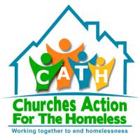

BOXING PROJECT

10-12PM EVERY TUESDAY

PICK UP AND DROP OFF AT CATH DAY CENTRE

ALL WELCOME!

Contact James or Andrea for more information on (01738) 633077

