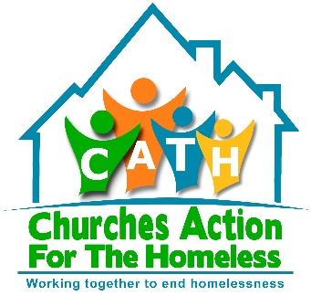
CHURCHES ACTION FOR THE HOMELESS
SLEEP OUT
St John’s Kirk, Perth
Wednesday 21st November 2018
ORGANISATION
NAME OF ALL PARTICIPANTS

CONTACT DETAILS
TEAM NAME

We recommend Teams of 5/6 persons. There is no registration fee, but we would like to ask if you can raise £250 sponsorship as a Team for local charity Churches Action for the Homeless.

